**EXPT- 8 DATE- 22-04-2021**

**AIM -> To implement a Program to Find Follow( ) of a Grammar.**

**THEORY -**

1. The first and follow sets are used in compiler designing process. The first() set is used in LL parsers which are top – down parsers that read or interpret from left to right.
2. The follow() set is used in LR parsers which are bottom-up parsers that read or interpret from right to left.
3. The LL parsers use leftmost derivations whereas the LR parsers use rightmost derivations. A predictive parser is constructed using first and follow sets that are associated with Grammar G.

PROGRAM = FOLLOWOF().c

INPUT - **E🡪TD**

**D 🡪+TD**

**D=$**

**T=FS**

**S=*FS**

**S=$**

**F=(E)**

**F=a**

OUTPUT -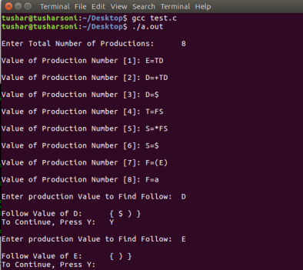

--------------------------------------------END------------------------------------------------------